Practical Assessment:

1. **Create asp.net mvc project called StudentDetails**.

ANS. Created the MVC project with name StudentDetails.

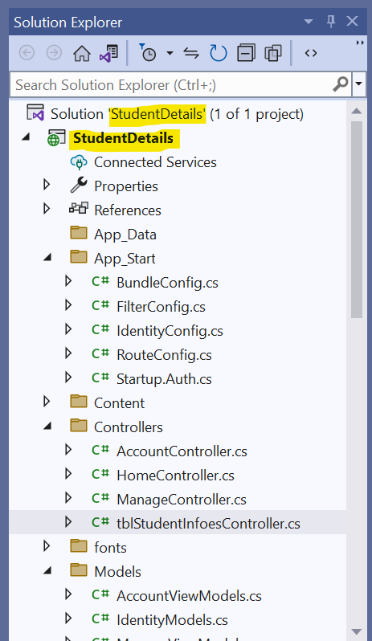

1. **Create SQL database with table name tblStudentInfo add few columns like StudentId, studentName, studentMobile, studentAddress, studentDept.**

Ans. Created the table “tblStudentInfo” with required parameters.

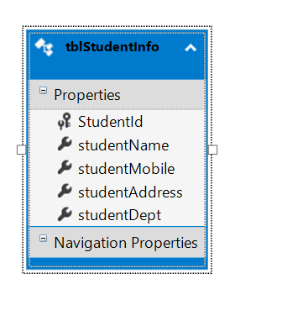

1. **Connect studentDetails app with above database using entity framework with database first approach with DBContext.**

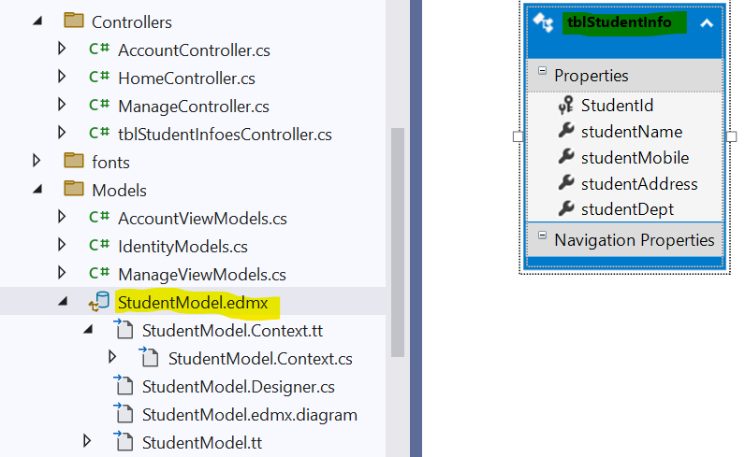



4**. Create student submission form using html helper class with data validation on model and use Task/Async/Await operator to insert into tblStudentInfo table using entity framework**.

  Ans.

1. Form with HTML helpers.

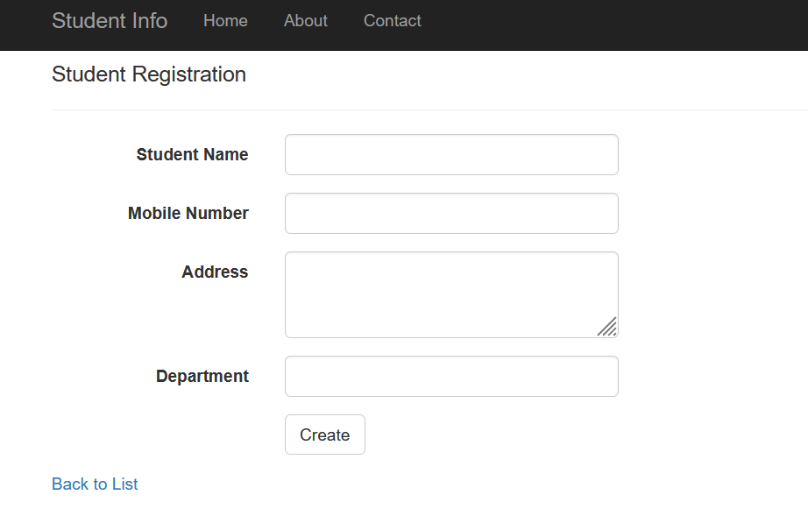

1. Data Validation.

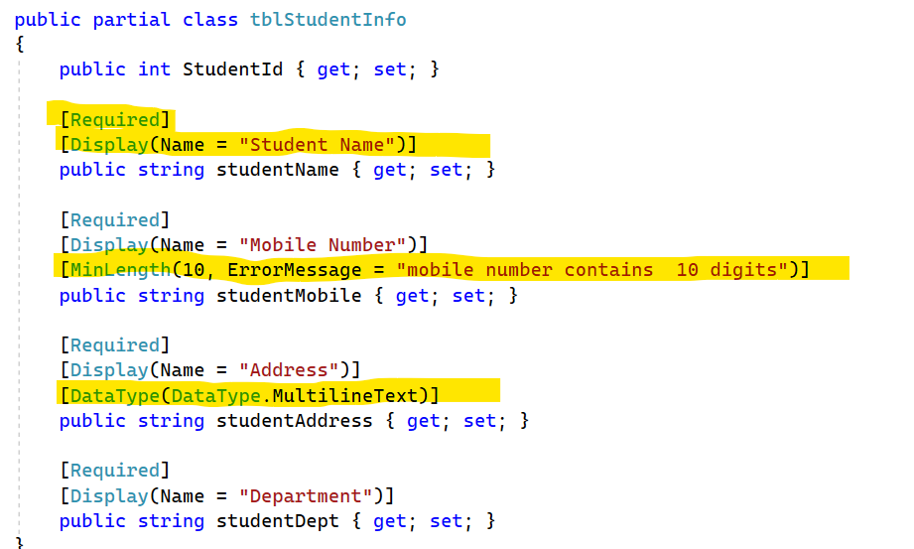

1. using Task/Async/Await operator to insert into tblStudentInfo table using entity framework

Ans. As inserting into table is nothing but adding a record .so, applied the above operators to create method.

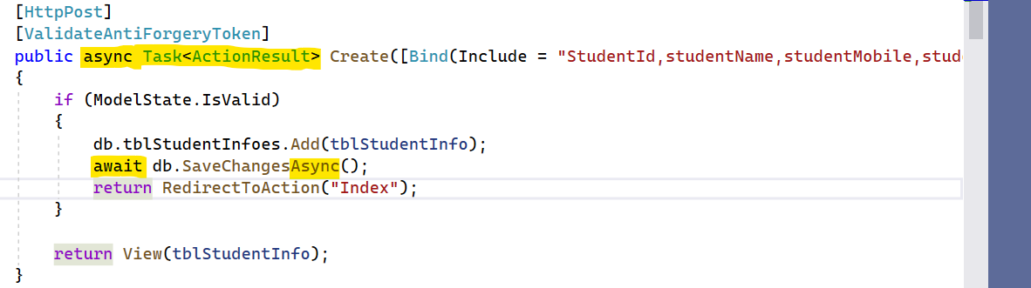

Below is the result when I clicked the home button.

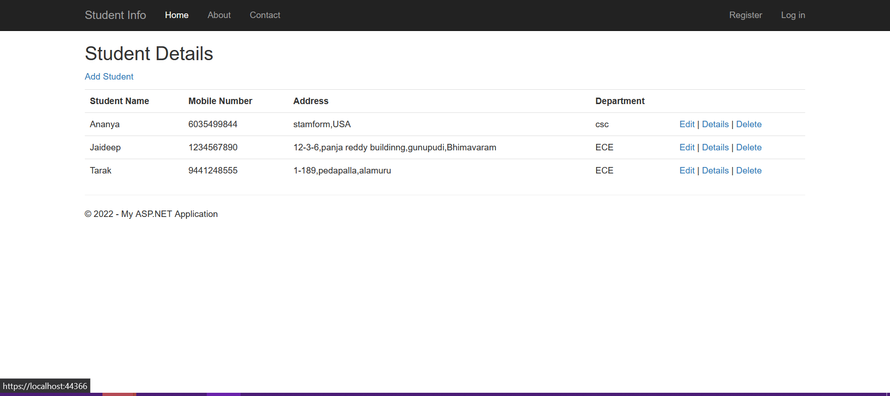

1. **Design the Home controller as landing page to display the list of all added Studentinfo into view and generate code through scaffolding for edit, update and delete into database.**

ANS.

1. Home controller as landing page to display the list of all added Studentinfo into view

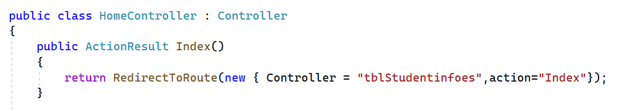

1. generate code through scaffolding for edit, update and delete into database.

